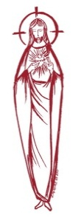
SACRED HEART PARISH

Sacred Heart Parish Founded 1814, The First Catholic Parish in the STate of New Jersey

Sacred Heart Church, 343 South broad Street, Trenton, New Jersey 08608

Holy Cross Church, 233 Adeline Street, Trenton, New Jersey 08611

ALL ARE WELCOME

Whatever your present status in the Catholic Church, whatever your current family or marital situation,

Whatever your past or present religious affiliation, whatever your personal history, age, background, or

race, whatever your own self-image or esteem, you are invited, welcomed, accepted, loved and

respected at the Parish of the Sacred Heart.

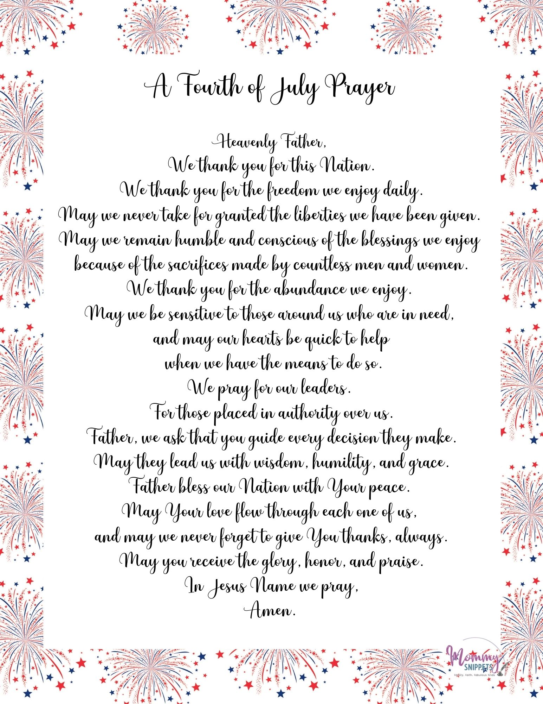
Thirteenth Sunday in Ordinary Time
July 2, 2023
MASS INTENTIONS
Saturday, July 1
4:00 pm ~ Catherine Bleier
5:15 pm SHC ~ Patrick Woodhead
Sunday, July 2
9:00 SHC ~ Claudette Souffront
10:00 HCC ~ Lottie Kostrzewa
11:15 SHC ~ The intentions of the people of the parish
12:00 HCC Polish ~ Jan Konecki
Monday, July 3
8:00 am HCC ~ No Mass
12:10pm SHC ~ No Mass
Tuesday, July 4
12:10 pm SHC ~ No Mass
Wednesday, July 5
12:10 pm SHC ~ Eileen Kostrzewa
Thursday, July 6
8:00 am HCC ~ Robert Szejner
Friday, July 7
8:00 am HCC ~ Special Intention
12:10pm SHC ~ Joseph Pfleger
Saturday, July 8
4:00 pm ~ John
5:15 pm SHC ~ Ken & Lucille Fisher and Brian Miller
Sunday, July 9
9:00 SHC ~ The intentions of the People of the Parish
10:00 HCC ~ Special Intentions
11:15 SHC ~ Thernelus Souffrant
12:00 HCC Polish ~ Zbigniew Kolodziej

OUR SICK LIST
Carole Minotti, Dolores DeBlasio, Ruby Covington, Judith Santigo, Ching Kukis, Dan Breese Jr, Brenna Kennedy-Moore, Dawn Chia, Mark Friedman, Robert Leighton, Patrick Leighton, Alexander A. Ladnyk, Kelly Nitti, Lauren Clayton, Joseph Edralin, Margie Tiongson, Kevin, Vincent Cooper, Jr., Gail Ladnyk, Leo Genovesi, Sloane Donnelly, Richard Buckley, Tony Ragolia, Barbara Burrows, Robert Mahon, Charles Burrows, Dorothy Amoroso, Maryann Sullivan, Regina Friedman, Rita Mich, Stanley Winowicz, Greg Schafer, Jack Hardiman, Paul Leighton, Amy Birk, Julia Grazioli, Matt and Leona Tydryszewski.

OUR DECEASED

John Matthews, Johanna Schino and our friends at South Village, Riverside Nursing and Rehabilitation Center, Mill House and Waters Edge.
MINISTRY SCHEDULE
(subject to change)
Saturday, July 1
4:00pm HCC ~ Fr Charles L. Benitez Em. R Micharski
5:15pm SHC ~ Msgr. Dennis L. L Bellina, Em. B Dumont, T Hines
Sunday, July 2
9:00 SHC ~ Msgr. Dennis L. M Komjathy, Em C&A Cruz
10:00 HCC ~ Fr. Charles l. A Dodson Em D Ezeuka
11:15 SHC ~ Msgr. Dennis L. B Allaire Em L Boyle, J Bautz
12:00 HCC Polish ~

Saturday, July 8
4:00pm HCC ~ Fr Charles L.M Herpel Em. L Bliznawiczus
5:15pm Msgr. Dennis L. C Hernandez, Em. J & K DiBenedetto
Sunday, July 9
9:00 SHC ~ Msgr. Dennis L. J Mc Donough, EM H & M Figueroa
10:00 HCC ~ Fr. Charles l. M Days Em Q Hilton
11:15 SHC ~ Msgr. Dennis L. J Blizard Em B Allaire J Diaz
12:00 HCC Polish ~ Fr Marian

WEEKLY COLLECTION
Last weekend’s collection amounted to $7,732.00. This includes the donations received in Church and the mail ins. Thank you for your continued support of our parish.

2023 ANNUAL CATHOLIC APPEAL UPDATE
Goal: $33,000.00 : Pledged: $43,556.00 (132% of Goal)

READINGS FOR THE WEEK
Thirteenth Sunday in Ordinary Time
Sunday 2 Kgs 4:8-11, 14-16a; Rom 6:3-4, 8-11; Mt 10:37-42
Monday Eph 2:19-22; Jn 20:24-29
Tuesday Gn 19:15-29; Mt 8:23-
Wednesday Gn 21:5, 8-20a; Mt 8:28-34
Thursday Gn 22:1b-19; Mt 9:1-8
First Friday Gn 23:1-4, 19, 24:1-8, 62-67; Mt 9:9-13
Saturday Gn 27:1-5, 15-29; Mt 9:14-17

PROMISE TO PROTECT
The Diocese of Trenton is committed to the norms of the U.S. Bishop’s Charter for the Protection of Children and Young People in regard to the reporting and investigation of sexual abuse allegations involving minors. If you have been sexually abused as a minor by anyone representing the Catholic Church, you can report that abuse through the diocesan Hotline: 1-888-296-2965 or via e-mail at abuseline@dioceseoftrenton.org. Allegations are reported to the appropriate law enforcement agencies.

. Sacred Heart Parish Picnic

We will honor Fr. Marcin Kania, who for two years was our priest who cared for the Spiritual needs of our Polish Community.
At the CYO of Mercer County
453 Yardville-Allentown Road.
Yardville, NJ 08620
July 9, 2023 ~ 1:00-5:00PM

MASS will be Celebrated at 1:15PM
at the Camp Grounds
Our parish will provide
Hot Dogs and Hamburgers, Rolls, Chips, Water and Soft Drinks
Please bring your own side dishes.

This year we ask all who attend to bring a dessert from your country of origin for the sharing table and attach a label to identify your country on the dessert.

PARKIING FOR THE PICNIC
is available in the parking lot
next to the CYO, which is behind
Saint Vincent de Paul Church

All Day Swimming, Games,
Outdoor Recreation, Playground Area
TEAR OFF BOTTOM PORTION AND RETURN
IN THE COLLECTION BASKET OR
SEND TO PARISH OFFICE BEFORE JULY 3rd
~~~~~~~~~~~~~~~~~~~~~~~~~~

Name: __________________________________
__________________________________________
Email address ____________________________

Number attending ___________
In celebration of our long Holiday Weekend, the parish office will be closed on Monday and Tuesday and will reopen on Wednesday July 5th. Also there are no Masses scheduled on Monday at 8:00am and 12:10 Noon
and on July 4th at 12:10 noon.

We had some computer issues the last few weeks and sad to say we missed the following names in our congratulatory announcement last weekend. Our apologies to the families.
Congratulations to:
Kristen Bruno
Sacred Heart University Grad School
Josh Smith
Seton Hall University

WEDDING ANNIVERSARY BLESSING
The Department of Evangelization and Family Life is pleased to announce the 2023 Bishop’s Anniversary Blessing for all couples celebrating a milestone anniversary of their Catholic Marriage. All couples celebrating their 1st, 25th or 50th (or more) anniversary in the 2023 calendar year are invited to attend. Anniversary couples must be validly married in the Catholic Church and registered members of a parish in the Diocese of Trenton. The Bishop’s Anniversary Blessing Mass for Mercer and Burlington County Parishes will be held on Sunday, October 22, 2023 at 3 pm in the Cathedral of St. Mary in Trenton. General information including online registration for anniversary couples can be found at www.dioceseoftrenton.org/bishops-anniversary-blessing.

RCIA – BECOMING CATHOLIC
Are you interested in becoming a Catholic? The desire to draw closer to God is in all of us, for we are his creation. Do you know an adult who would like to find out about what we believe? Do you know anyone who has not completed the Sacraments of Communion and Confirmation, and would like to? Please prayerfully consider who might be interested in entering more fully into the Catholic faith and invite them to join us for our “Inquiry session” scheduled to begin in September. Please contact Msgr. Dennis at
Frdennis@trentonsacredheart.org or
609-393-2801 ext. 102..

RELIGIOUS EDUCATION NEWS
Parents are asked to reregister their children on or before the last class. Re-registration forms are available online or from Mary Tovar. The tuition fee is $65.00 per child.

NEW REGISTRATIONS ACCEPTED
Parents who have children beginning their Religious Education are asked to register as soon as possible. You can obtain the form on our web page or by calling the parish office.

COMMUNION AND CONFIRMATION CLASS
If you have a child who is ready to make his or her First Communion or Confirmation, the Diocesan guideline requirement is that they complete two years of Religious Education. For First Communion your child must attend First and Second year of Religious Ed and for Confirmation the child must
complete grade 7 and 8 before receiving the Sacrament of Confirmation. Please be sure to register soon.

CALENDAR 2023 - 2024
We are in the process of setting a calendar for the July 2023 to June 2024 year. If your society, group or organization is planning to meet on our campus, please submit your groups calendar by July 24th to John at the parish office. Email
Secretary@trentonsacredheart.org.

HOLY FATHER COLLECTION
With roots leading back to the seventh century, the annual Peter’s Pence Collection will take place in the Diocese of Trenton July 2, aiming to contribute to Pope Francis’ charitable works worldwide.
Collected each year globally on the weekend closest to the Feast of Sts. Peter and Paul, the Peter’s Pence Collection enables the Holy Father to respond to emergencies with financial assistance, directing funds to those most in need as a result of war, oppression and natural disasters. Participation in the collection also allows faithful Catholics to respond tangibly in a way that empowers the weak, defenseless and voiceless, as well as to sustain those suffering. More information: http://www.peterspence.va/en.html

DATES FOR SACRAMENTS
Our dates for the reception of the Sacraments have been scheduled for next year. They are:
Reconciliation: March 2, 2024 10:00am
First Communion: May 4, 2024 10:00am
Confirmation: May 7, 2024 6:00pm

THANK YOU FROM SHIRLEY TURNER
Dear Sacred Heart Family,
Please accept my heartfelt appreication … for your kind and generous contributions to my 2023 Community Book Drive. This year I partnered with Darlene McKnight Elementary School and had the privilege of serving 350 students. [We] provided nearly 5000 books to the school. Thank you again for your continued support…
Sincerely, Shirley Turner, Senator – 15th District

THANK YOU TO THE KNIGHTS OF
SAINT JOHN
Thank you brother Knights for you generous donation to our Sacred Heart Food Pantry, as you celebrated your patrons feast day last weekend. Our needy neighbors will benefit from your Chrsitian Service for them. Thank you.

ST FRANCIS HOUSE OF PRAYER
7- DAY CENTERING PRAYER RETREAT
August 6 – 13
A Centering Prayer retreat invites you to go more deeply into the silence and stillness, which facilitates growth in Contemplative Prayer and attentiveness to God’s Word. Donation: $600; $100 non-refundable deposit with registration.

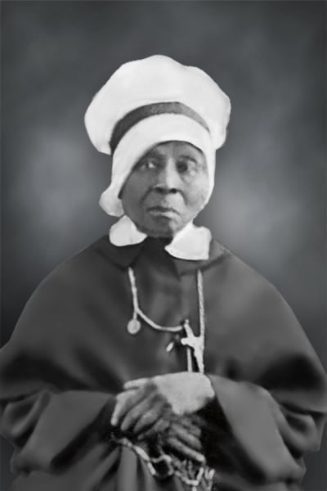

Mother Mary Elizabeth Lange, founder of the first Catholic order of African American nuns.

Mother Lange is important to our parish because her Order, The Oblate Sisters of Providence, taught in Our Lady of Divine Shepherd School, Trenton, for many years. Our Lady of Divine Shepherd is one of the parishes that merged into Sacred Heart in 2018.

POPE DECLARES MOTHER MARY ELIZABETH LANGE ”VENERABLE”
VATICAN CITY CNS – Recognizing they lived the Christian virtues in a heroic way, Pope Francis has declared venerable Mother Mary Elizabeth Lange, founder of the first Catholic order of African American nuns, and Sister Lúcia dos Santos, who, with her cousins, reported seeing Mary when she was a child in Fátima, Portugal. The Pope signed the decrees recognizing their heroic virtues June 22. A miracle attributed to their intercession is still necessary before they can be beatified. Mother Lange, who was born in Cuba to Haitian parents, came to the United States around 1813, settling near Baltimore, and saw how the children of other immigrants needed education. "She was determined to respond to that need in spite of being a black woman in a slave state long before the Emancipation Proclamation," according to the official website of her sainthood cause. "She used her own money and home to educate children of color." With the encouragement and support of a priest and Archbishop James Whitfield of Baltimore, she and three other women made promises of poverty, chastity and obedience in 1829, founding the Oblate Sisters of Providence, an order that continues today. Mother Lange died in 1882.
Servant of God, Mother Mary Lange (1787-1882)
Mother Mary Lange was born Elizabeth Clarisse Lange in a French speaking community in Santido de Cuba. By 1813 Elizabeth arrived in Baltimore, Maryland where there were no schools for black children. For many years she offered education for those children in her home. She is the founder and first superior of the Oblate Sisters of Providence, the first successful religious community for women of African Descent. The community educated the youth and slaves who had been purchased and freed, provided a home for orphans & elderly and nursed the terminally ill. During times of poverty and racial injustice, Mother Mary never lost faith in Providence. Her perseverance and endurance are signs of her close union with God which she boldly asserted “Our sole wish is to do the will of God.” until she went home to be with Him on February 3, 1882. Mother Mary Lange lived a Spirit-filled life.
Prayer for the Canonization of Mother Mary Lange
Almighty and Eternal God, You granted Mother Mary Lange extraordinary trust in Your providence. You endowed her with humility, courage, holiness and an extraordinary sense of service to the poor and the sick. You enabled her to found the Oblate Sisters of Providence and provided educational, social and spiritual ministry especially to the African American community. Mother Lange’s love for all enabled her to see Christ in each person, and the pain of prejudice and racial hatred never blurred that vision. Design to raise her to the highest honors of the altar in order that, through her intercession, more souls may come to a deeper understanding and more fervent love of You. Heavenly Father, glorify Your heart by granting also this favor (here mention your request) which we ask through the intercession of Your Faithful servant, Mother Mary Lange. Amen.

SAINT MARIA GORETTI
Feast Day, July 6th
It was one of those days where you can sit outside to do your work. Maria was sewing up a shirt while her mother and siblings were out on the farm working. A young man she knew, Alessandro, snuck up on her and began to attack her. “No, no you mustn’t! What you are doing is a sin!” screamed Maria. Alessandro stabbed her many times. A couple of days later she died from those wounds. Before she died, she forgave her attacker and promised to pray for him. She said: “I forgive Alessandro Serenelli… and I want him with me in heaven forever.”
Mara had been born into a Catholic family on October 16, 1890. Her family was very poor after Maria’s father died, but her family’s love for God never wavered. Every day Maria’s mother and brothers and sisters went out into the fields to work. Maria stayed behind and took care of all the household responsibilities including cooking, sewing, and taking care of the youngest child, Teresa, who was still too young to work out in the fields. (Can you imagine having all those responsibilities when you were only twelve years old? Having to cook all of dinner? Maybe the next time your mom asks you to set the table, think about all the chores St. Maria had and don’t complain!)
After Alessandro attacked Maria, he was captured and sent to prison for thirty years. At first he wasn’t sorry for his sin. Then one day he had a dream. In the dream, he was sitting in a garden with Maria and she gave him a bunch of lilies. When he took them, the flowers burned his hands. Upon awakening, Alessandro was a changed man, sorry for his sins. When Alessandro was released from prison, he found Maria’s mother and asked for forgiveness. She responded, “If my daughter can forgive him, who am I to withhold forgiveness?”
On June 24, 1950 Maria Goretti was declared a saint by Pope Pius XII. Alessandro was present at the beatification. Eventually, Alessandro joined the order of Friars Minor Capuchin as a lay brother. He worked there as both a gardener and receptionist until his death.

RETROUVAILLE
Tens of thousands of couples have healed their marriages through Retrouvaille (pronounced Retro-vy). Couples learn to build communication skills and to increase intimacy. It provides help for marriage problems, difficulties or crises. The Office of Family Life, Diocese of Metuchen, will sponsor a Retrouvaille weekend on August 18-20. For further information, please contact Rich Colasuonno (732-236-0671) or Annette Colasuonno (732-672-0748) or email 3024@helpourmarriage.org. The Family Life Center in Malvern, PA will hold Retrouvaille weekends on August 18 - 20 and October 6 – 8. For more information, or to register, visit www.HelpOurMarriage.org or call 215-766-3944 or 800-470-2230. All inquiries are strictly confidential.

HOW DID THE 4th OF JULY BECOME

A NATIONAL HOLIDAY ?
For the first 15 or 20 years after the Declaration was written, people didn’t celebrate it much on any date. It was too new and too much else was happening in the young nation. By the 1790s, a time of bitter partisan conflicts, the Declaration had become controversial. One party, the Democratic-Republicans, admired Jefferson and the Declaration. But the other party, the Federalists, thought the Declaration was too French and too anti-British, which went against their current policies.
By 1817, John Adams complained in a letter that America seemed uninterested in its past. But that would soon change. After the War of 1812, the Federalist party began to come apart and the new parties of the 1820s and 1830s all considered themselves inheritors of Jefferson and the Democratic-Republicans. Printed copies of the Declaration began to circulate again, all with the date July 4, 1776, listed at the top. The deaths of Thomas Jefferson and John Adams on July 4, 1826, may even have helped to promote the idea of July 4 as an important date to be celebrated. Celebrations of the Fourth of July became more common as the years went on and in 1870, almost a hundred years after the Declaration was written, Congress first declared July 4 to be a national holiday as part of a bill to officially recognize several holidays, including Christmas. Further legislation about national holidays, including July 4, was passed in 1939 and 1941.

